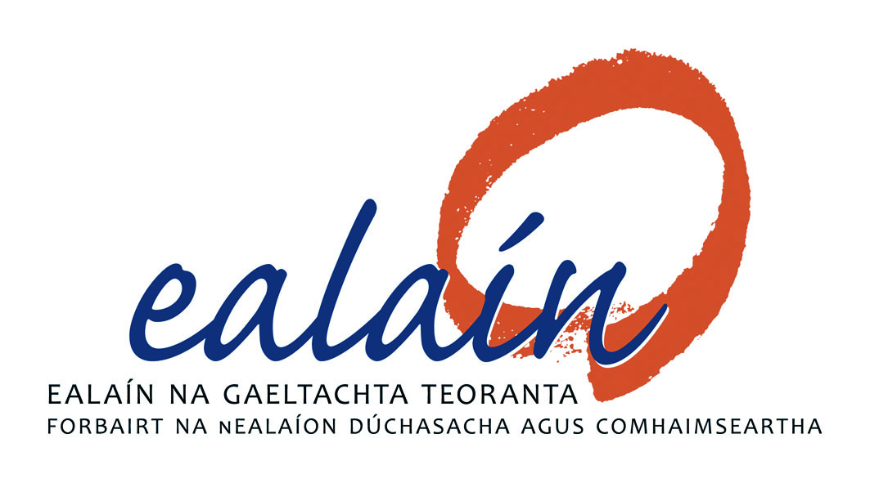
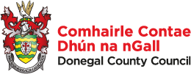

Togra Pobal Ealaíon
@ Áislann Ghaoth Dobhar

Údarás na Gaeltachta, Ealaín na Gaeltachta & Comhairle Contae Dhún na nGall

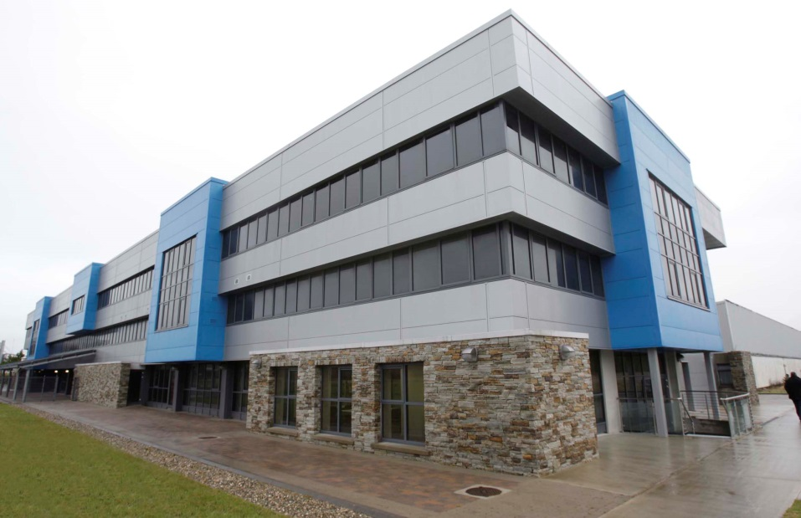
Permanent Artwork with Engagement
Budget: €50,000

Stage 1: Briefing Document & Application
Deadline: Friday, 5th April, 2019, 4pm.

- Introduction: Páirc Ghnó Ghaoth Dobhair

An Introduction –Background

The North West Donegal Gaeltacht encompasses the parishes of Na Rosa, Gaoth Dobhair and Cloich Cheann Fhaola. The distinctive regional character of this unique rural area is defined by the Irish language and culture, its recognition as an area outstanding natural beauty and its high population density.

High rural population density is a feature of many of the townlands within this area and they rank amongst the highest in the Republic of Ireland. This is largely a legacy of the displacements and upheavals of the Ulster Plantation, 1641 Rebellion and the Population Explosion of the 18th and early 19th Centuries.

In the past these areas were called ‘congested districts’ and it was generally recognised that the limited agricultural/natural resources could not support the population. Alternative means of support were necessary and came in the form of cottage industries, fishing and turf cutting. However, one of the key sources of income was from the labour of seasonal migrants to Scotland and from children who were hired out at Ulster Hiring Fairs, practices which survived well into the 1960s and were key contributors to the survival of these rural communities.

“Chaith mé cúig nó a sé de shéasúir ar an Lagán go dtí gur éirigh mé mór agus urrúnta. Ansin dar liom go rachainn go hAlbain mar a rinne mo dhaoine romham. Ba é an gnás a bhí ann sa tsaol sin gasúr a ghabháil cúpla séasúr chun an Lagáin sula dtéadh sé go hAlbain.”

Scéal Hiúdaí Sheáinín ; Eoghan Ó Domhnaill, (1940)

Emigration and hiring out were a fact of life for most families in the Donegal Gaeltacht. The general pattern was that the father and oldest son left home to work in Scotland as soon as they had planted their crops in the springtime. Similarly, children as young as eight years old were taken to hiring fairs in Letterkenny or Strabane, and hired out for around six months, Both groups returned in late November or December. The winter months were for family and reunion.

Women, children and older members of the community stayed at home where the traditional way of life continued. Seasonal migration effectively allowed communities to compartmentalise to the use of language. English was necessary only for work in Scotland or the Lagan, Irish remained the language of the home place. Even then, when working in groups only the ‘foreman’ or ‘ganger’ needed to speak English to make a deal with farmers or other employers.

In the absence of the men, women stepped into the breach and the area effectively became a matriarchal society. They were often in charge of the households, holdings and in control of family income. Women contributed to the household income through raising poultry, selling eggs and butter, and knitting. Their labour and the income from seasonal migration and the hiring fairs sustained these communities and their traditional way of life.

Gradually farming practices changed and became more mechanised. Peoples’ expectations also changed and in the absence of local employment a period of intense emigration began in the 1950s and 60s. During this period entire family groups left in search of employment and for better opportunities.

Background to the Business Park

For the first time since before the Great Famine – the area was unique in that the population increased following the Famine - the population of the west Donegal Gaeltacht was in decline. This worrying trend and the negative economic and cultural effects of continued emigration in the area spurred six local business men into action. Tomás Mac Giolla Bhríghde, Michael McGinty, Séamus Shields, Charlie Greene and Éamonn Kelly, with the support of Séamus Ó Rághallaigh, a government official, and the local community activists challenged the status quo. They had the vision and commitment to develop an Industrial Estate in North West Donegal. They knew that employment was vital to retaining the population of this Gaeltacht area and consequently to the survival of the language. The outcome of their actions was the establishment of one of the first planned rural Industrial Estates in the Republic of Ireland which attracted inward investment and helped to stem the flow of emigration from the area.

They succeeded in transforming the employment landscape in the North West Gaeltacht forever more and served as a catalyst to further develop new business in the North West region.

Establishing the Estate/ Business Park

By June 1968, the first of three advance factories was completed and on the 27 November 1968, Amblers Teoranta, a textile company, was officially opened.

The Derrybeg Industrial Estate continued to expand over the next three decades – the 70s, 80s and 90s. During that period, Údarás na Gaeltachta attracted a diverse range of manufacturers to the area, which included companies involved in sub-assembly electronics, textiles, automotive components, snack food manufacturing and engineering.

The numbers employed peaked at a total of 1,338 employees in 1998. Like much of the rest of Ireland, over the next five years, businesses on the Industrial Estate were exposed to a global downturn and to the increasing trend in outsourcing manufacturing to the low cost economies of the East, such as India and China. This lead to a dramatic downturn in the workforce on the Industrial Estate. The Financial Crisis of 2008 and the economic downturn that followed had further serious consequences for the Business Park and for employment across a broad range of sectors in the Gaeltacht and once again emigration was on the rise.

The Derrybeg Industrial Estate had to regroup and adapt to the changing circumstances in order to refresh and attract new investment across a range of sectors and activities – from both Irish owned firms and foreign direct investment. This included the rebranding of the Derrybeg Industrial Estate in 2002. It is now known as Páirc Ghnó Ghaoth Dobhair / The Gweedore Business Park, which is once again rising to the challenge of becoming the economic hub which will serve the local community of the north-west Gaeltacht.

Change of fortune for Gaoth Dobhair Business Park

Gaoth Dobhair Business Park has experienced a period of sustained growth, both in employee numbers and the new businesses which have been attracted to the Business Park. The Business Park now employs 570 people, the vast majority of whom are employed by private companies - 80 are employed by state bodies. These figures represent a significant change of fortune for Údarás na Gaeltachta’s Gaoth Dobhair Business Park, which is the largest enterprise and industry-based business park in West Donegal.

A key component of Údarás na Gaeltachta's revitalisation plans for the Business Park is the Áislann Ghaoth Dobhair complex. Áislann Ghaoth Dobhair opened in 2011, a traditional manufacturing unit that has been converted into a three storey state of the art Innovation and Enterprise Complex. The centre has a range of outstanding facilities and provides additional services to the local community in the form of a crèche/childcare facility which caters for over a 100 preschool children, an Art Exhibition Centre and a Regional Library Facility located on the ground floor.

The 1st & 2nd floor of Áislann Ghaoth Dobhair is home to the digital hub network that was established as part of Gréasán Digiteach na Gaeltachta, GTEIC@Gaoth Dobhair, which is a key component of Údarás na Gaeltachta’s business development strategy in promoting innovation throughout the Gaeltacht and Islands. GTEIC@Gaoth Dobhair contains a range of modern office spaces of various sizes, hot desks, a conference room (top-of-the-range video conferencing facilities), meeting rooms, incubation and enterprise units dedicated to the needs of the ICT and Knowledge Based Technology Enterprises and also that hosts a twenty seat Digital Hub.

The Áislann Ghaoth Dobhair complex represents a modern day Gaeltacht with the vibrancy and vitality of Irish speaking entrepreneurs redefining a new narrative for Páirc Ghnó Ghaoth Dobhair.

Conclusion – the story reflected through art

We invite an art commission that reflects the various narratives and stories relating to Páirc Ghnó Ghaoth Dobhair. The commission may commemorate the history of the Industrial Estate/Business Park, the socio-economic and cultural history of the North West Gaeltacht. Furthermore, the work may acknowledge the contribution of those who were involved in the founding of the industrial estate/business park, the community groups and the emigrants. The various trades that were practiced, the shift from agricultural/ fishing work practises to manufacturing is an important part of the narrative as well as those who have worked there over the years.

Coimisiún / Nature of the Work
The nature of the work sought is a site-specific, visual artwork which it is envisaged will be sited outdoors, on or in the immediate vicinity of the Áislann building. It is expected that the artwork, in addition to reflecting the theme of the commission- as outlined above – should create a sense of identity and place for the Áislann building. It should have a positive interactive and visual impact in a space that is both modern and active and that serves as a centre for innovation, creativity and technology. The work should also enhance its surroundings and provide a cultural and historical context for the people who use and visit the business park. The commissioners are keen that the artwork should attract people to the Áislann building and must be permanent in nature.

The work might link to different narratives and stories relating to Páirc Ghnó Ghaoth Dobhair. It could commemorate the history of the business parks and might also reflect the socio-economic and cultural history of the Gaoth Dobhair Gaeltacht. Furthermore, the work may acknowledge those were involved in the founding of the industrial estate/business park, the various trades that were practiced, as well as those who have worked there over the years.

The brief asks the artist/s to note the following:
- The work may be a sculptural piece, an installation incorporating a variety of media, or any another visual work that the artist believes reflects and satisfies the objectives of the commission.
- The work and its constituent materials will need to be of a robust nature, capable of withstanding the prevalent weather conditions of the exposed, coastal location of the site
- The artwork should direct people to the Áislann building.
- The proposed process must involve artists making new site-specific work as a central aspect of the commission and engagement with key stakeholders including, service users, staff and the wider community.
- Research and understanding of the nature of the site, built surroundings and environment are essential as is a commitment to the Health and Safety policy of Údarás na Gaeltachta.

Site Location
The Commissioners wish that the work be sited on, or in the vicinity of, the Áislann building in Páirc Ghnó Ghaoth Dobhair, Na Doirí Beaga, Leitir Ceanainn, Contae Dhún na nGall.
Please see the Site Map and Photographic images, as attached.

The Commissioning Process:
The Commissioners will employ a Two-Stage Open Competition Process to select a suitable practitioner(s) to deliver the Commission. It is open to all interested professional artists at any stage of their career or experience. Selection will be based on the information supplied and how that establishes the competence of the artists to carry out this commission.

Stage 1
Artists are invited to express their interest in being considered for this project at the first stage of this commission.

Interested practitioners are invited to submit the following to the Commissioners:
- Application form; Curriculum Vitae; a brief Artist’s Statement - accompanied by preliminary drawing(s) only – indicating how they might propose to engage with this commission; images / details of recent relevant works / projects; AND a sample selection of recently completed Public Art Commissions (if relevant). No designs or detailed proposals are required at Stage 1.

Site Visit:
A Site Visit has been organised for interested artists, at 11 am on Thursday, 7th March, 2019, when they may view the Áislann building and its environs, be briefed on the Commissioner’s aims and goals for the project and get response to any additional queries they may have in relation to the Commission.

Completed Stage 1 Submissions should be lodged by post to the below address by 4pm Friday, 5th April, 2019.

Togra Pobal Ealaíon @ Áislann GD
F/ch: Danielle Nic Pháidín
Údarás na Gaeltachta,
Páirc Ghnó Ghaoth Dobhair,
Na Doirí Beaga,
Leitir Ceanainn,
Co. Dhún na nGall.

Please take note of the following:
- Submissions by fax or email will not be accepted.
- All materials submitted should be clearly labelled with the applicants name and contact details.
- Late submissions will not be accepted
The closing date for receipt of Stage 1 completed application form together with supporting documentation and material is 4pm Friday, 5th April, 2019.
__________________________________________________________________

Stage 2
From the completed Stage 1 applications; a shortlist of artists will be selected by panel jury.
This panel, whose decision is final, has the right to clarify any issue which may arise in the
course of selection.

Those successfully selected for Stage 2 be invited to submit a more detailed submission. This will involve the provision of a Model/Maquette of the proposed work, a Statement by the Artist outlining their Artistic Vision behind the work, a detailed Description of the proposed work including Materials to be used, Maintenance Schedule and an Engineer’s Report and a detailed Project Budget.
As part of the evaluation of Stage Two proposals, applicants may be invited to outline their proposals in the form of a presentation to the Selection Board.
For Stage Two Submissions, the Commissioners will pay the Artist a premium of €500, upon delivery of their proposal by the date and time suggested.

- Budget
The total anticipated budget for the project is €50,000. This includes the costs of any materials, artist’s fees, design development, artist’s insurance, supply and installation, signage, travel, VAT and any other costs incurred in the production of the project / artwork.
The artist will be responsible for meeting all of these costs out of the total budget allocated.

- Selection Panel
The Selection Panel will consist of four members of the Public Art Working Group and a Professional Artist/artist representative and will be chaired by the manager of the Áislann facility.

- Project Delivery Timeline
It is anticipated that the project will be of a 7/8 month period, to commence during
Apr/May 2019. The deadline for installation of this artwork is set for November 2019. The final timeline will be agreed and to be confirmed with the commissioned artist at contract stage. The artist should demonstrate their ability to fulfil this timeframe to the best of their ability.

- Selection Criteria
Artistic Merit and Concept 30%
Response/Adherence to brief 30%
Feasibility/demonstrated ability potential of the artist 30%
Value for money/budget 10%

- Queries
Applicants can make enquiries regarding the commission to Danielle Nic Pháidín, by telephone + 353 74 60100 or by email d.nicphaidin@udaras.ie

Site Map and Photographic Images of Áislann Ghaoth Dobhair

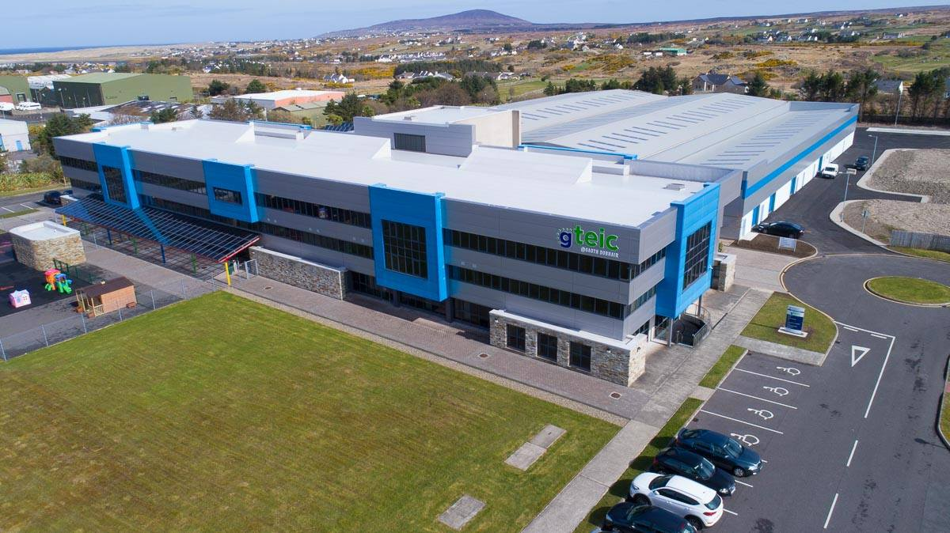

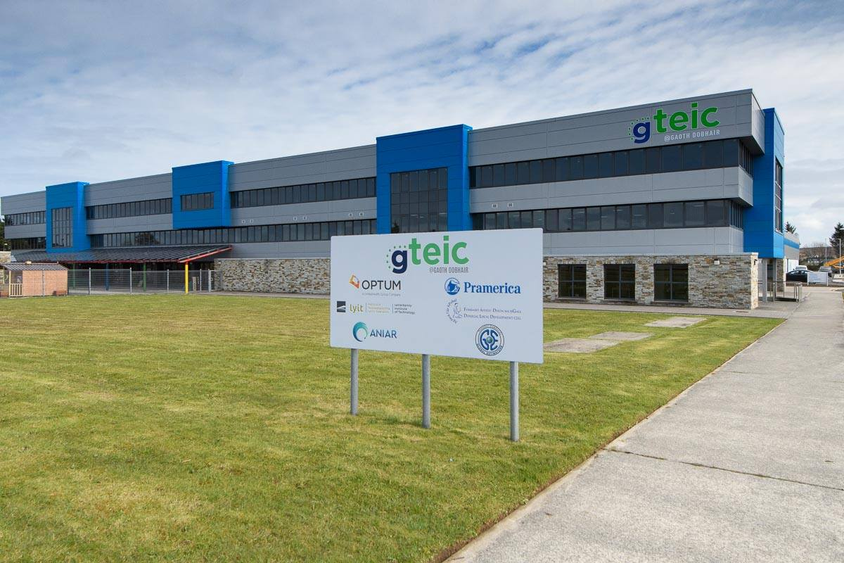

Site Map

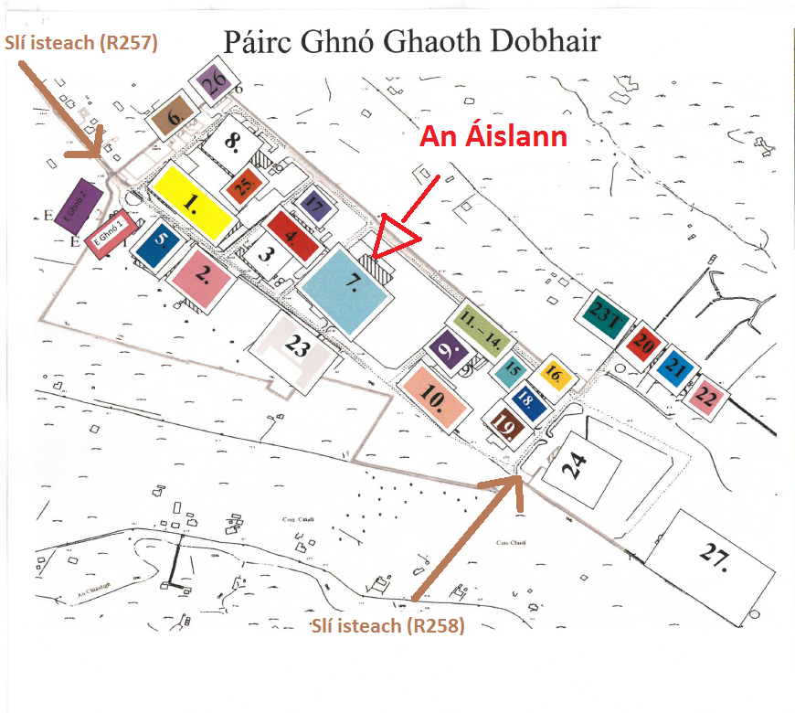

Togra Pobal Ealaíon @ Áislann Ghaoth Dobhar
Stage 1 – Application Form

Name: ____________________________________

Address: (please note all correspondence will be sent to this address)

______________________________________________________________________________
Telephone number:_______________________ E-mail: ___________________________

1) Please give short description of your art practice, its relevance to this project and why you would like to work on this commission:

2) Artists are asked to submit the following:
- Detailed Curriculum Vitae
- List of previous relevant projects or commissions, date, cost, time scale to deliver,
list of specialist or other contractors engaged by the artist in connection with the
completion of these installations
- Visuals of previous work relevant to this commission brief
- Names of 2 referees and their contact details
- Confirmation that, if successful, the artist is ready to submit a current Tax Clearance
Certificate / Access Number, or an Artist Exemption Certificate and to provide required insurances. This confirmation is mandatory.

3) Supporting Documentation:
To assist in the assessment of your application, supporting documentation should be included and should be clearly labelled on submission:
Please confirm the supporting documentation and Number of Items Enclosed in the table below:

Item | Enclosed | No. of Items
CV

CDs/DVDs / USB

Other, please specify
___________________________
___________________________
___________________________

Freedom of information:
Applicants completing this form should note that information provided to Public Art @ Áislann GD Working Group may be disclosed in response to a request made under
the Freedom of Information Act (1997 and 2003). Every effort will be made to protect client
confidentiality.

Garda Vetting:
The successful artist may be subject to Garda vetting procedures.

Declaration
I have read the award conditions, agree to be bound by them, and certify that the information in this application is correct to the best of my knowledge.

Signed ____________________________________

Date ____________________________________

This application form and supporting information should be returned by HARD COPY to the
address below:

Togra Pobal Ealaíon @ Áislann GD,
F/ch: Danielle Nic Pháidín
Údarás na Gaeltachta,
Páirc Ghnó Ghaoth Dobhair,
Na Doirí Beaga,
Leitir Ceanainn,
Co. Dhún na nGall

Closing date for the receipt of completed applications is 4pm Friday, 5th April, 2019.

Please note that applications received after the closing date and time will not be accepted.
Emailed applications cannot be accepted.

