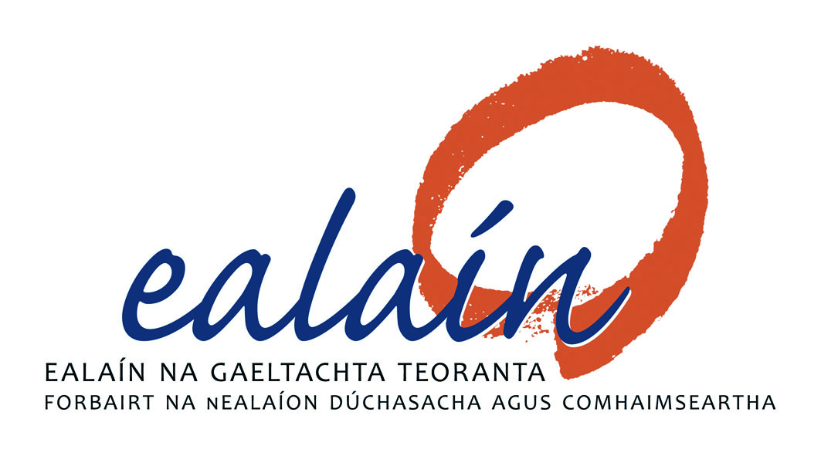

Togra Pobal Ealaíon @ Áislann Ghaoth Dobhar
Stage 1 – Application Form

Name: ____________________________________

Address: (please note all correspondence will be sent to this address)

______________________________________________________________________________
Telephone number:_______________________ E-mail: ___________________________

1) Please give short description of your art practice, its relevance to this project and why you would like to work on this commission:

2) Artists are asked to submit the following:
- Detailed Curriculum Vitae
- List of previous relevant projects or commissions, date, cost, time scale to deliver,
list of specialist or other contractors engaged by the artist in connection with the
completion of these installations
- Visuals of previous work relevant to this commission brief
- Names of 2 referees and their contact details
- Confirmation that, if successful, the artist is ready to submit a current Tax Clearance
Certificate / Access Number, or an Artist Exemption Certificate and to provide required insurances. This confirmation is mandatory.

3) Supporting Documentation:
To assist in the assessment of your application, supporting documentation should be included and should be clearly labelled on submission:
Please confirm the supporting documentation and Number of Items Enclosed in the table below:

Item | Enclosed | No. of Items
CV

CDs/DVDs / USB

Other, please specify
___________________________
___________________________
___________________________

Freedom of information:
Applicants completing this form should note that information provided to Public Art @ Áislann GD Working Group may be disclosed in response to a request made under
the Freedom of Information Act (1997 and 2003). Every effort will be made to protect client
confidentiality.

Garda Vetting:
The successful artist may be subject to Garda vetting procedures.

Declaration
I have read the award conditions, agree to be bound by them, and certify that the information in this application is correct to the best of my knowledge.

Signed ____________________________________

Date ____________________________________

This application form and supporting information should be returned by HARD COPY to the
address below:

Togra Pobal Ealaíon @ Áislann GD,
F/ch: Danielle Nic Pháidín
Údarás na Gaeltachta,
Páirc Ghnó Ghaoth Dobhair,
Na Doirí Beaga,
Leitir Ceanainn,
Co. Dhún na nGall

Closing date for the receipt of completed applications is 4pm, Friday 5th April 2019.

Please note that applications received after the closing date and time will not be accepted.
Emailed applications cannot be accepted.

